**Pizza sales SQL project**

1. Retrieve the total number of orders placed.

* select count(order_id) as total_orders from orders;

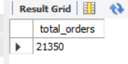

1. Calculate the total revenue generated from pizza sales.

* SELECT

SUM(orders_details.quantity * pizzas.price) AS total_sales

FROM

orders_details

JOIN

pizzas ON orders_details.pizza_id = pizzas.pizza_id

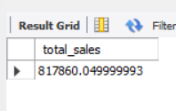

1. Identify the highest-priced pizza.

* SELECT

pizza_types.name, pizzas.price

FROM

pizza_types

JOIN

pizzas ON pizza_types.pizza_type_id = pizzas.pizza_type_id

ORDER BY pizzas.price DESC

LIMIT 1;



1. Identify the most common pizza size ordered.

* SELECT

pizzas.size,

COUNT(orders_details.order_details_id) AS order_count

FROM

pizzas

JOIN

orders_details ON pizzas.pizza_id = orders_details.pizza_id

GROUP BY pizzas.size

ORDER BY order_count DESC

LIMIT 1;

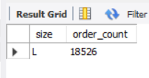

1. List the top 5 most ordered pizza types along with their quantities.

* SELECT

pizza_types.name,

SUM(orders_details.quantity) AS order_quantity

FROM

pizza_types

JOIN

pizzas ON pizza_types.pizza_type_id = pizzas.pizza_type_id

JOIN

orders_details ON orders_details.pizza_id = pizzas.pizza_id

GROUP BY pizza_types.name

ORDER BY order_quantity DESC

LIMIT 5;

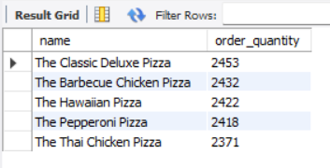

1. Join the necessary tables to find the total quantity of each pizza category ordered.

* SELECT

pizza_types.category,

SUM(orders_details.quantity) AS category_quantity

FROM

pizza_types

JOIN

pizzas ON pizza_types.pizza_type_id = pizzas.pizza_type_id

JOIN

orders_details ON orders_details.pizza_id = pizzas.pizza_id

GROUP BY pizza_types.category

ORDER BY category_quantity DESC;

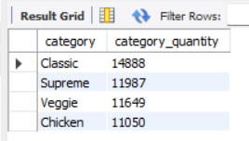

1. Determine the distribution of orders by hour of the day.

* SELECT

HOUR(order_time) AS hour, COUNT(order_id) AS order_count

FROM

orders

GROUP BY HOUR(order_time);

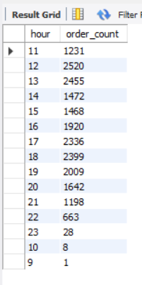

1. Join relevant tables to find the category-wise distribution of pizzas.

* select category, count(name) from pizza_types

group by category;

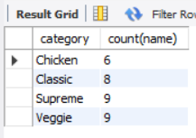

1. Group the orders by date and calculate the average number of pizzas ordered per day.

* SELECT

ROUND(AVG(quantity), 0) as avg_pizza_ordered_per_day

FROM

(SELECT

orders.order_date, SUM(orders_details.quantity) AS quantity

FROM

orders

JOIN orders_details ON orders.order_id = orders_details.order_id

GROUP BY orders.order_date) AS order_quantity;

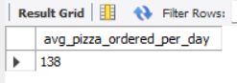

1. Determine the top 3 most ordered pizza types based on revenue.

* SELECT

pizza_types.name,

SUM(ROUND((orders_details.quantity * pizzas.price),

0)) AS revenue

FROM

pizza_types

JOIN

pizzas ON pizza_types.pizza_type_id = pizzas.pizza_type_id

JOIN

orders_details ON orders_details.pizza_id = pizzas.pizza_id

GROUP BY pizza_types.name

ORDER BY revenue DESC

LIMIT 3;

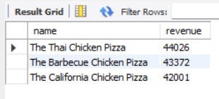

1. Calculate the percentage contribution of each pizza type to total revenue.

SELECT

pizza_types.category,

round(SUM(orders_details.quantity * pizzas.price) / (SELECT

SUM(orders_details.quantity * pizzas.price) AS total_sales

FROM

orders_details

JOIN

pizzas ON orders_details.pizza_id = pizzas.pizza_id) * 100, 3)

AS contribution_of_each_pizza_type

FROM

pizza_types

JOIN

pizzas ON pizza_types.pizza_type_id = pizzas.pizza_type_id

JOIN

orders_details ON orders_details.pizza_id = pizzas.pizza_id

GROUP BY pizza_types.category

ORDER BY contribution_of_each_pizza_type DESC;

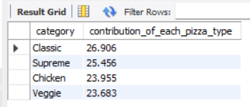

1. Analyze the cumulative revenue generated over time.

* select order_date,

sum(revenue) over(order by order_date) as cumulative_revenue

from

(select orders.order_date,

sum(orders_details.quantity * pizzas.price) as revenue

from orders_details join pizzas

on orders_details.pizza_id = pizzas.pizza_id

join orders

on orders.order_id = orders_details.order_id

group by orders.order_date) as sales;

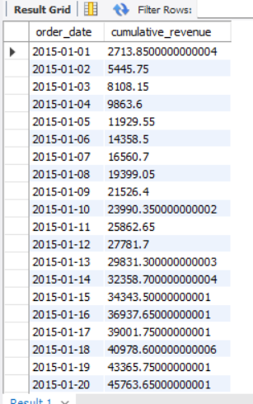

1. Determine the top 3 most ordered pizza types based on revenue for each pizza category.

* select name, category, revenue

from

(select category, name, revenue,

rank() over(partition by category order by revenue desc) as rnk

from

(select pizza_types.category, pizza_types.name,

sum((orders_details.quantity) * pizzas.price) as revenue

from pizza_types join pizzas

on pizza_types.pizza_type_id = pizzas.pizza_type_id

join orders_details

on orders_details.pizza_id = pizzas.pizza_id

group by pizza_types.category, pizza_types.name) as a) as b

where rnk <= 3;

